***GENERATING STUDENT DETAILED MARKS***

***CERTIFICATE (DMC) USING FILE HANDLING IN C++***

* When I run the program, my console will look like this. I will provide all the information whitch the compiler will prompt me to enter like roll no, name, college name and select my group according to the given.

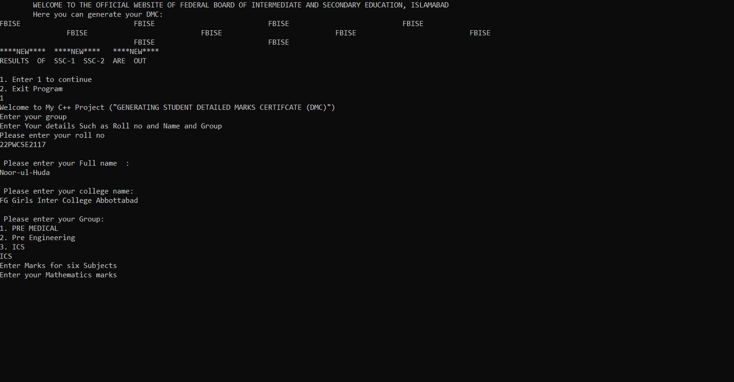

* Then the compiler will prompt me to enter the marks for six subjects based on my group.

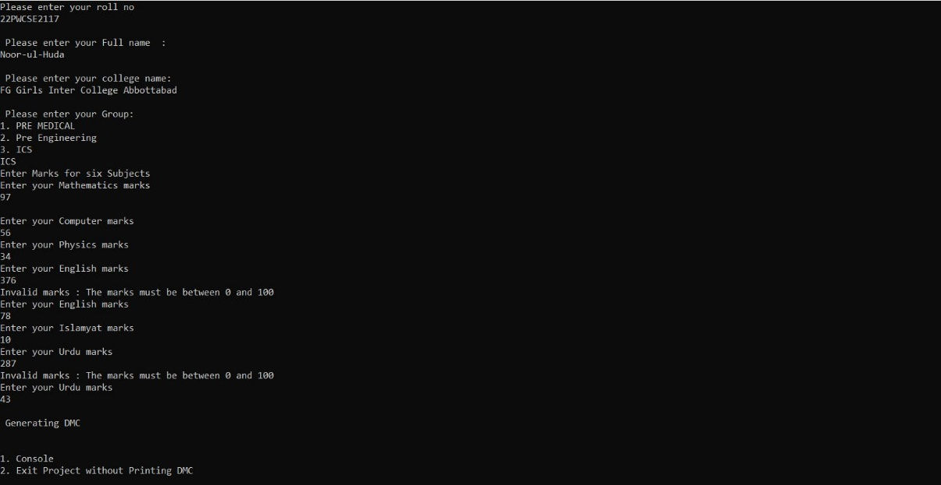

* Then it will prompt me to enter whether you want to console your DMC or exit without Printing DMC. When I entered 1 my screen will look like this:

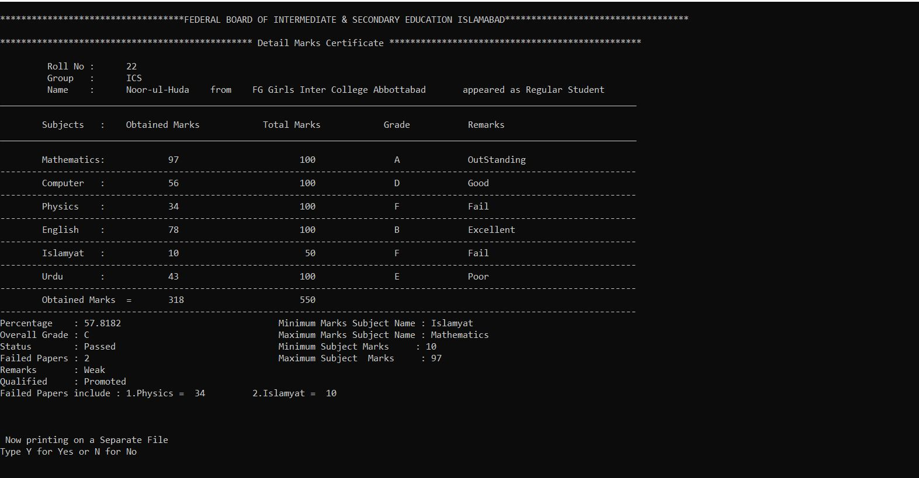

* As I used file handling in this project so the compiler will prompt that whether you want to print DMC on a separate file.
* When you entered Y or y my screen will look like this:

NOTEPAD FILE:

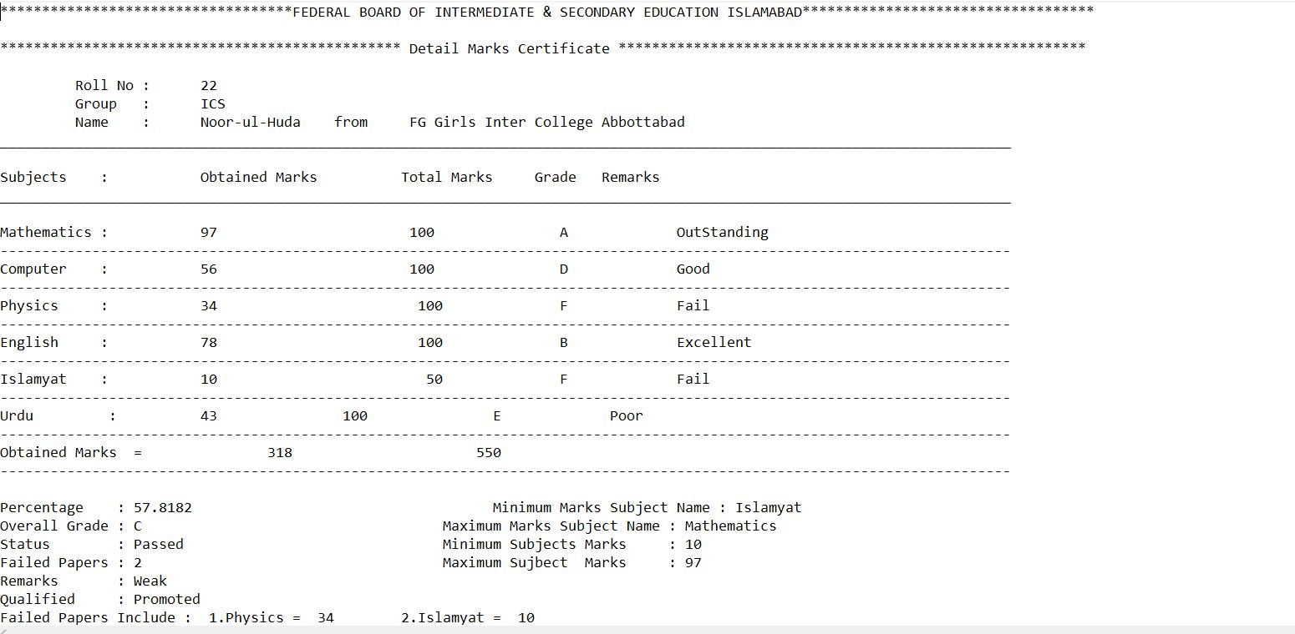

* A file will open in notepad and we can save this file for printing purposes.

The end